# **Random Forest Model**

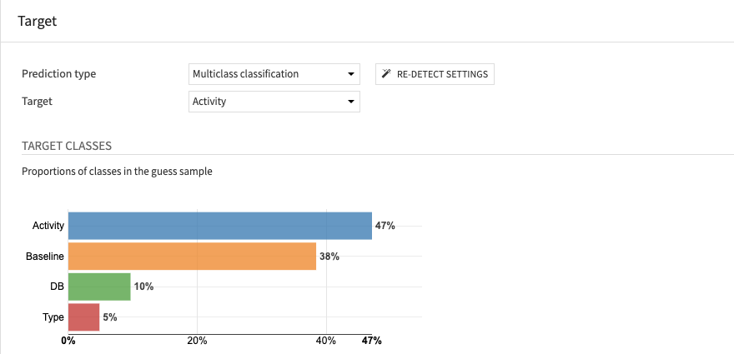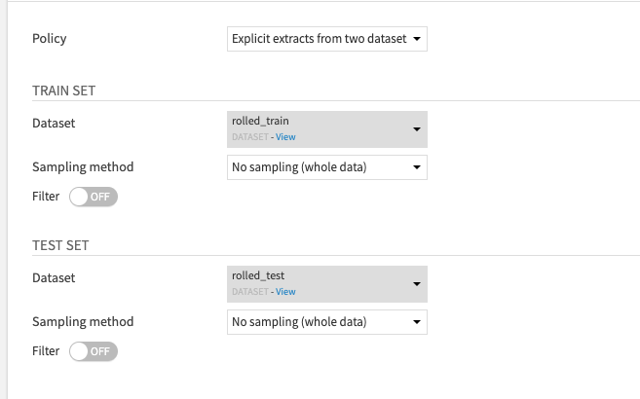

## **Model Input**

* Data was rolled on 10-second means
* Rolled_train contains 80% of the data, grouped by subject_id (80% of the subjects)
* Rolled_test contains 20% remaining data
* Target Variable: Activity
* Features: ACC1, ACC2, ACC3, TEMP, EDA, BVP, HR, Magnitude
  + Standardization rescaling (mean 0, sd 1)
* 100 trees in the forest
* 13 maximum depth of the tree, 1 minimum sample per leaf
* Class weights applied to ensure that despite class imbalance, the trained model takes each class equally into account
* The main metric to test upon is **F1 score**

## **Model Output**

### F1 score

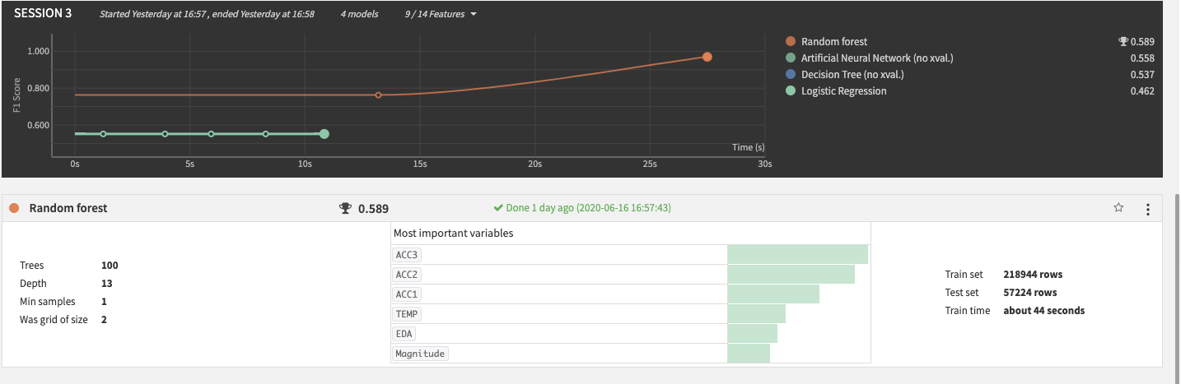

### Example of a Decision Tree

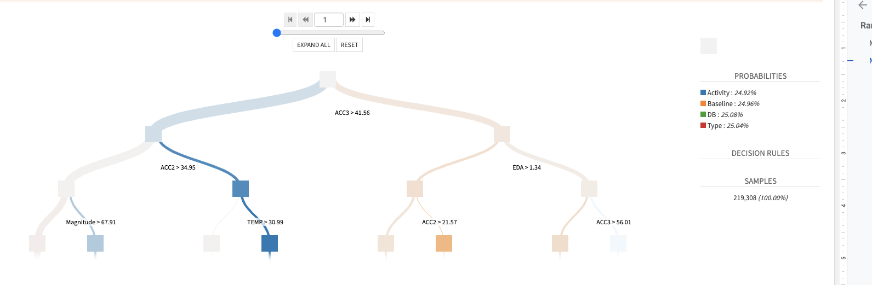

### Variable Importance

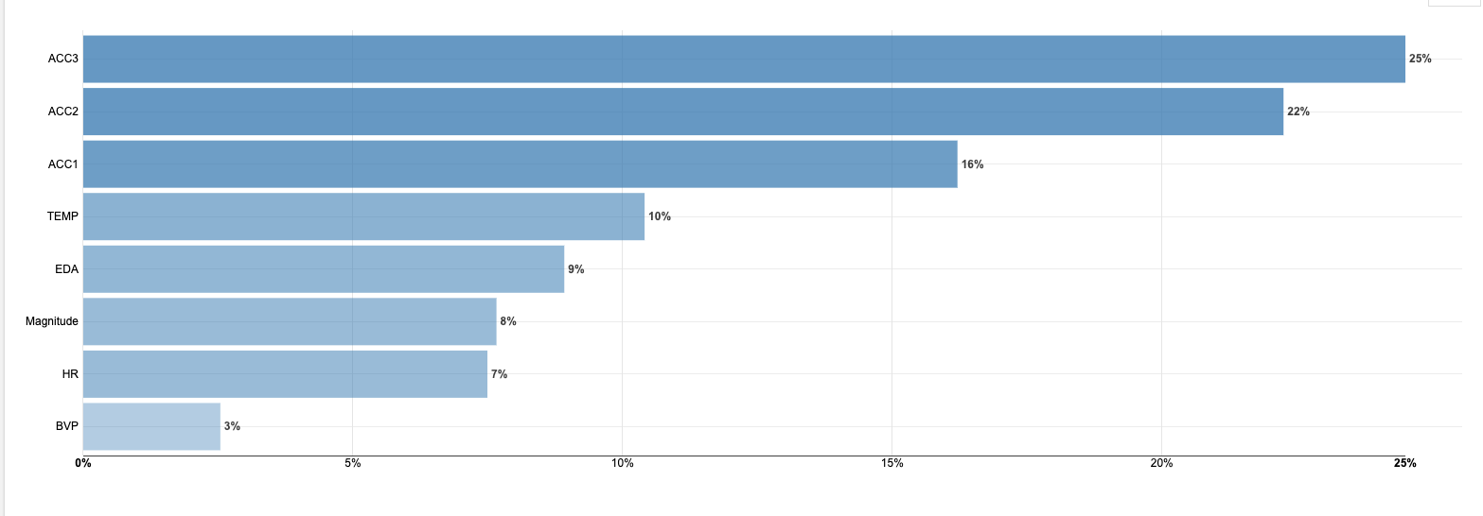

### Confusion Matrix

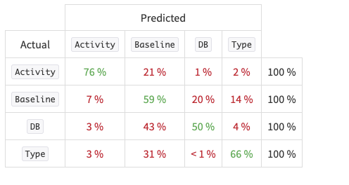

### Detailed Metrics

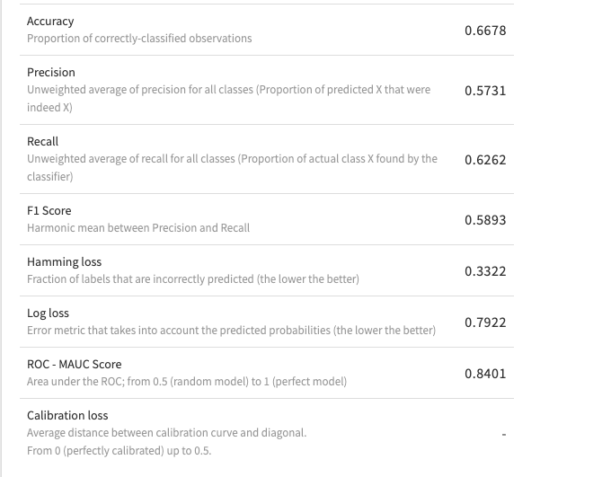

### Algorithm Details

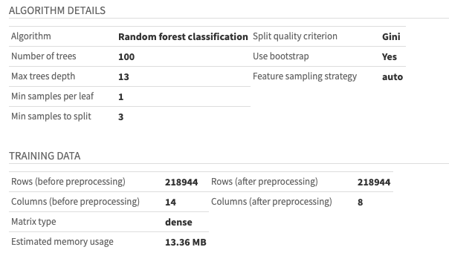

### Partial Dependence

